Let's now take a closer look, at the table mode. Just click the Table button, and you'll see the screen changes.

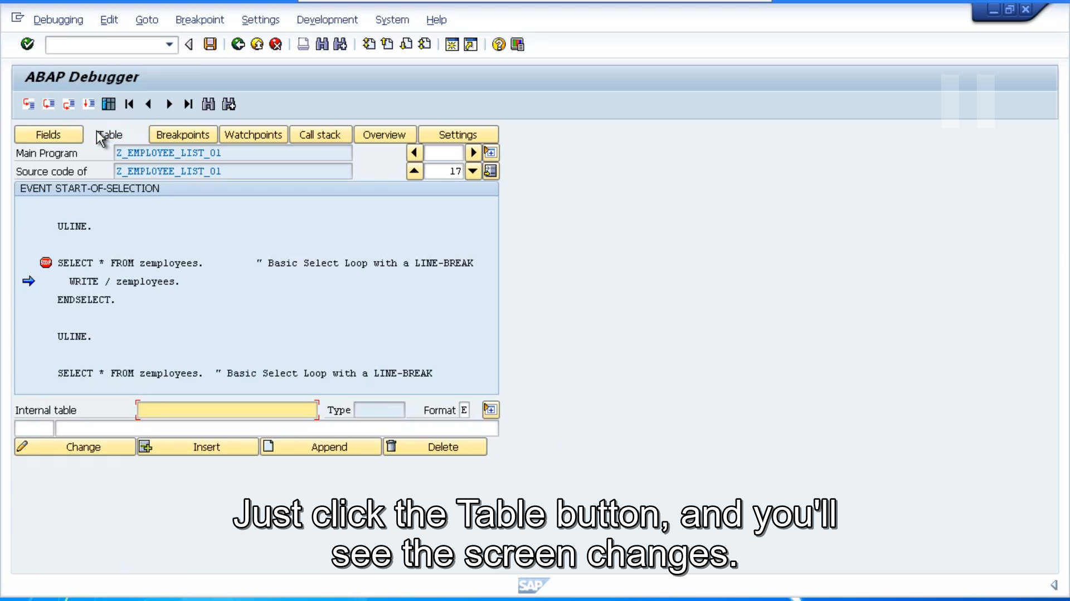

We still have a code section, but then the lower section, has now changed to show an entry for an Internal Table and then a single row. We haven't covered Internal Tables yet in this ABAP course, but for now you just need to be aware that, an Internal Table is just a table or records that are stored in memory while the program is running. The table mode option, allows us to interrogate the records and fields of each record of an Internal Table.

As we did with the fields mode section, you can either double click on an Internal Table that has been defined in your ABAP code, or you can enter the Internal Table Name directly into the internal table input field.

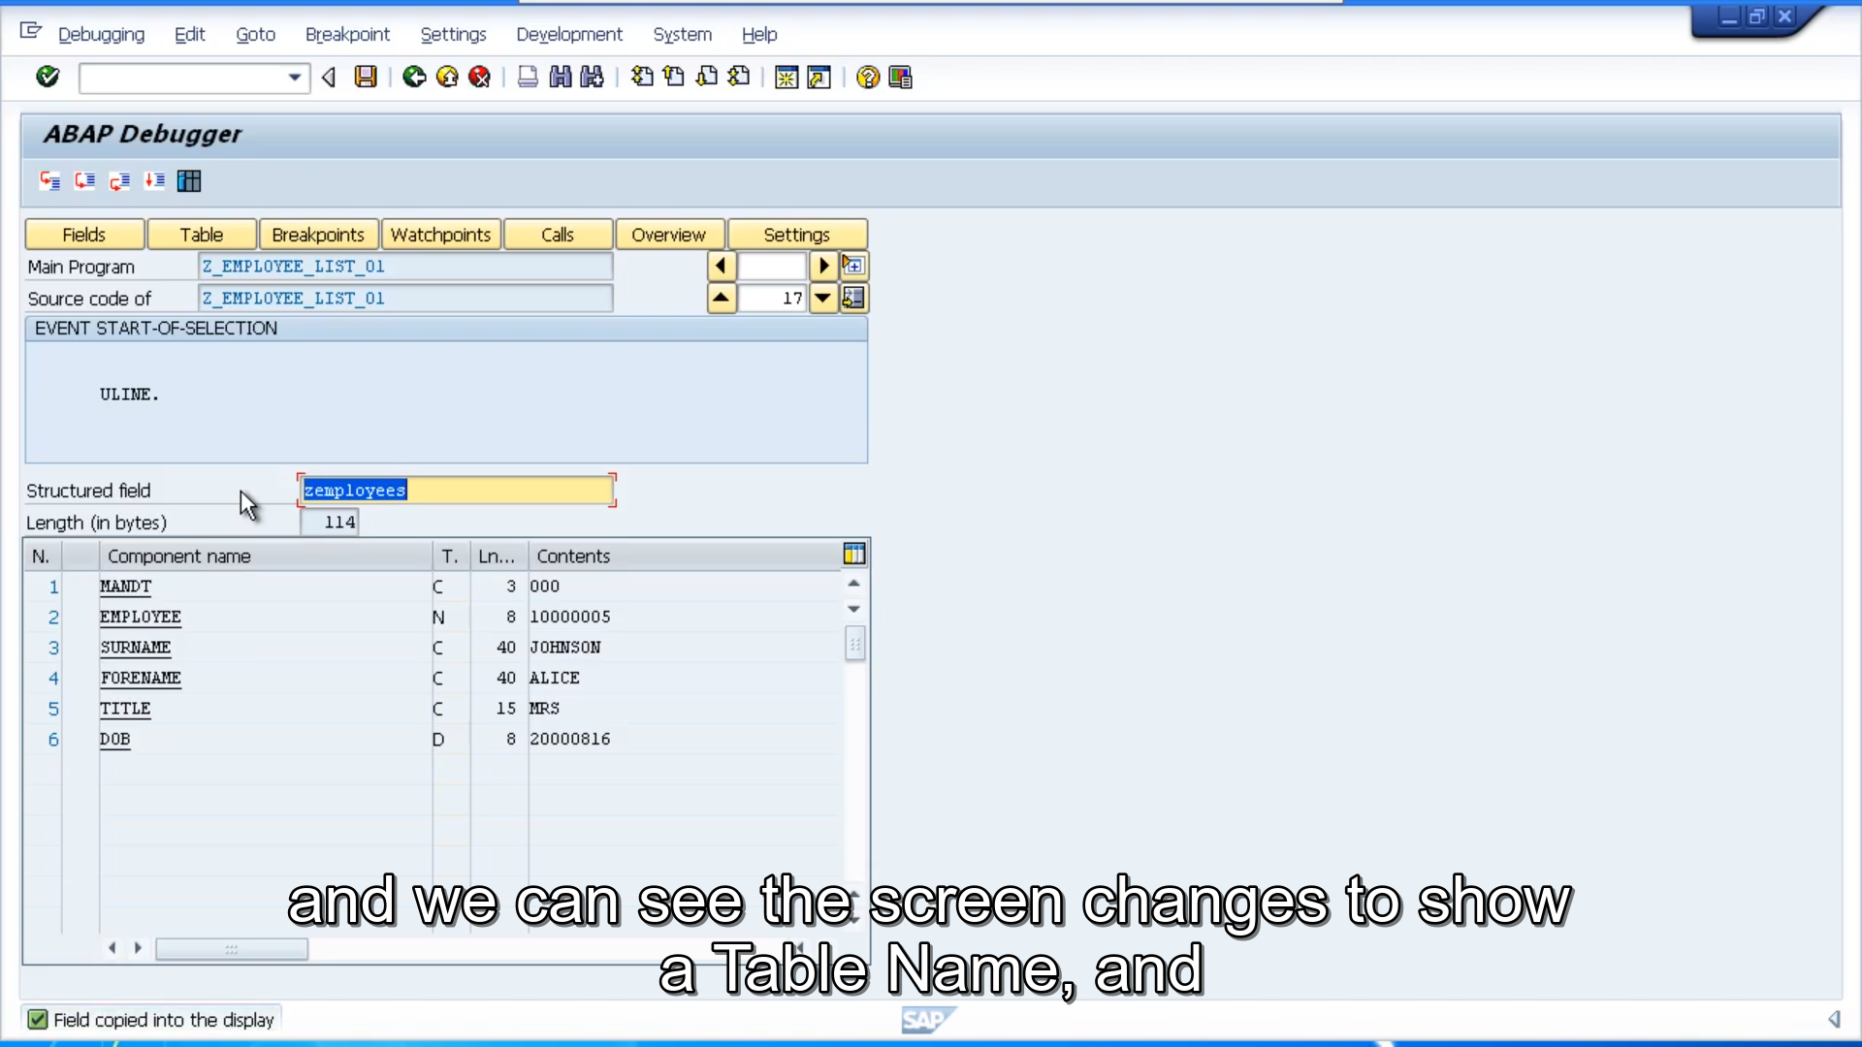

So, for example, I can double click on this Z Employees Table, and we can see the screen changes to show a Table Name, and below it the individual fields together with their contents. So, as you can see it's very similar to the fields mode. And that you'll see the Field Name and the Field Contents. Table mode allows us to see a whole Internal Table. Now in this example, things do look a little different to normal, because I'm actually dealing with a table structure right now. We haven't declared an actual Internal Table itself. And the program is just using table structure, which results in a table list like this, showing the individual fields listed one to six with their content. When viewing Internal Tables, you will see a slightly different layout. Where you'll see, a number of records for each internal table, with the content, and then you can double click on those Records to then show this layout, which shows the individual fields for each record.

As we move along in this course, we will be debugging our programs, and looking at proper internal tables, and you'll see the screen layout then. As we did with the Field List section, you can now navigate up and down the Field List. And interrogate the contents of the table and the individual fields, and you can continue debugging your program in table mode, and see how your program code changes the table contents. Now, I don't often do that myself, because as you'll notice, the screen that's your code section, has become very small. You only get what one, two, three, three lines of code that are visible. So, as you step-by-step go through your code, you can see, you don't actually get to see much about code. Only the couple of lines surrounding the statement, that it's currently executing. So more often than not, I'll have a look at the Table, I'll have a look at the Contents, find out the information I want and then switch back to fields mode. [SOUND] And you can switch between these different modes of the debugger, any time you like.